Design process:
Originally, my partner and I set off on our own to create our chart designs. We talked about our chosen data set which tracked misinformation in AI on different platforms. We pointed out a couple of important data points that we would reflect on. Platform, Model signature, and amount of incorrect responses were strong points. After discussing the potential points we could use, we set out to make our own charts and ideas.
Following the FdS approach of implementation, my original ideas were all over the place. I was writing down any different order of data and chart types. I sampled dot plots, bar graphs, and line charts. I was basically just trying to find out what stuck out to me and what fit the data the best.
Next, in the filter section singled out each type of chart and what data would fit into them the best. I settled on Volume of entries, platform and model signature for the bar graph idea. In this stage I decided that instead of a dot plot, I would have 2 different ideas for the line graph. For one line graph I settled on Volume of entries, time, platform, and model signature. For the other, I went with volume of entries, time and platforms (with an emphasis on platforms).
After deciding on my filters, I began categorizing my graphs and fleshing them out. For one line graph, I made one that marks the model signature for each different platform depending on month. For the other graph I did the same thing but combine everything all at once and it’s a bit overwhelming. For the bar graph, I had 3 bars per platform all being measured against the volume of entries. Each bar represented a type of model signature.
For the combine and refine section, I decided to combine both of my line charts. I realized that in Tableau, I can have multiple graphs linked to each other in the same workbook. I decided to just make separate charts for each platform and then make one that included all the combined platforms. For the bar graph, I didn’t change it much. I like how simplistic it was, not too confusing but still gave solid information about the topic.
For the Bar graph initial design, I essentially did everything I already mentioned. I changed nothing, but explained more and when hovering over a bar, it shows more specific information.
For the line chart initial design, I also did everything I already explained. I plan to incorporate buttons that can allow users to go in between charts for each platform. There will also be a button to show all platforms combined.
My last initial idea I had to come up with something on the fly since I was already satisfied with the two. I ended up making a dotted chart that resembles a bar graph. This graph essentially takes what is shown in my bar graph idea, but it also includes the months. The dotted bars are shrunk and compared to each month, depending on platform. Each platform gets its own symbol so that it doesn’t get too confusing. Also allows zoom to see a clearer representation.
When sharing our finished ideas, we decided that Calebs Pie chart idea would be the more persuasive graph. This was because it had an easy-to-understand pie chart with percentages. It catches your eye and once you’re looking at the chart, you can read the other information towards the bottom. For the 3 clearer charts, we settled with my line charts, Caleb’s scatter plot, and a bar graph.
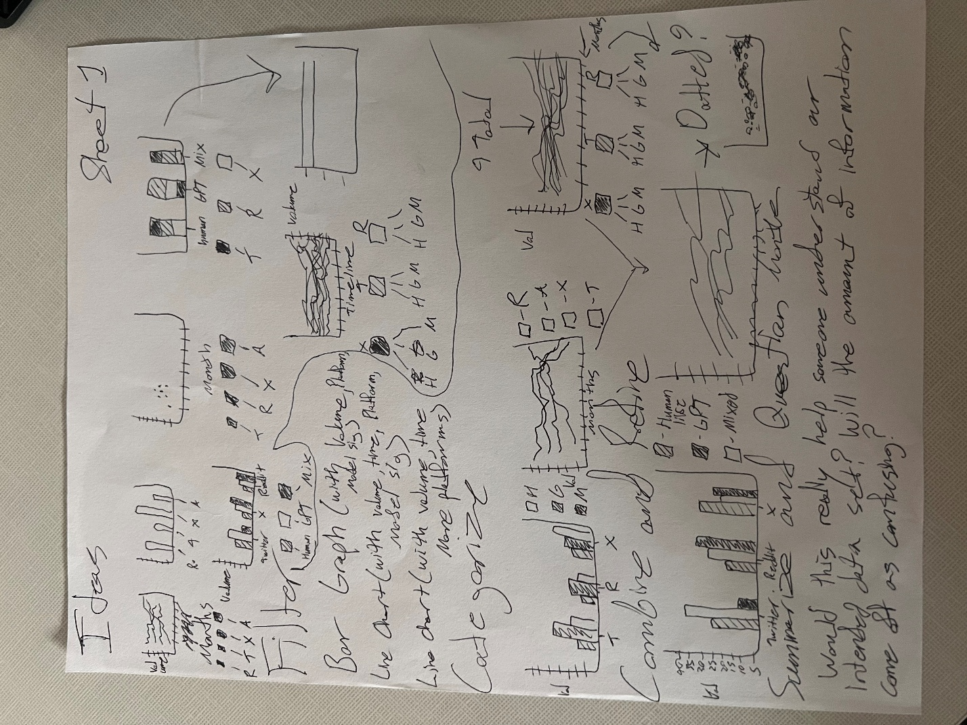
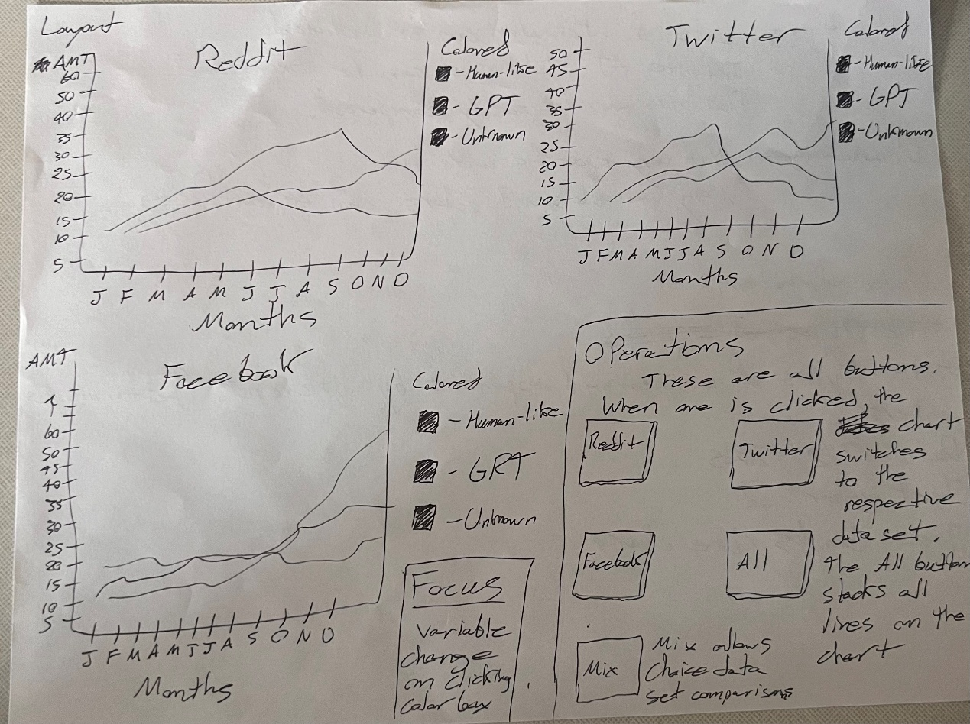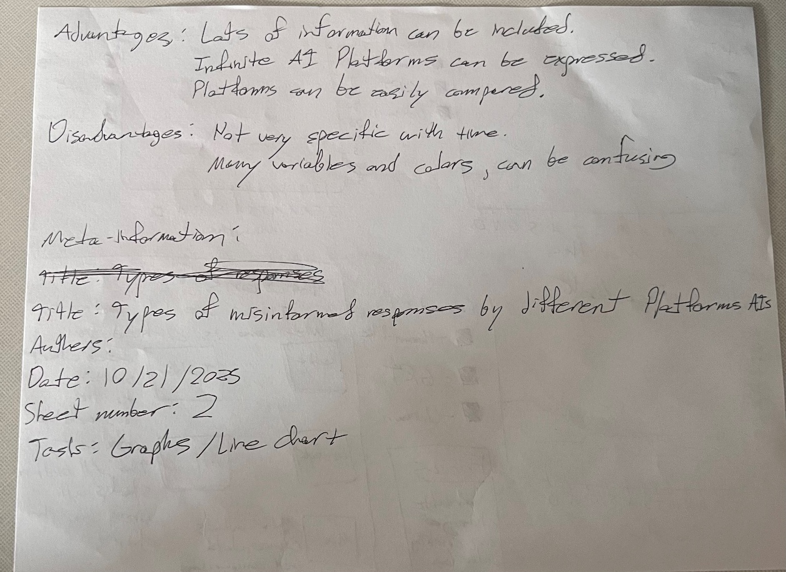

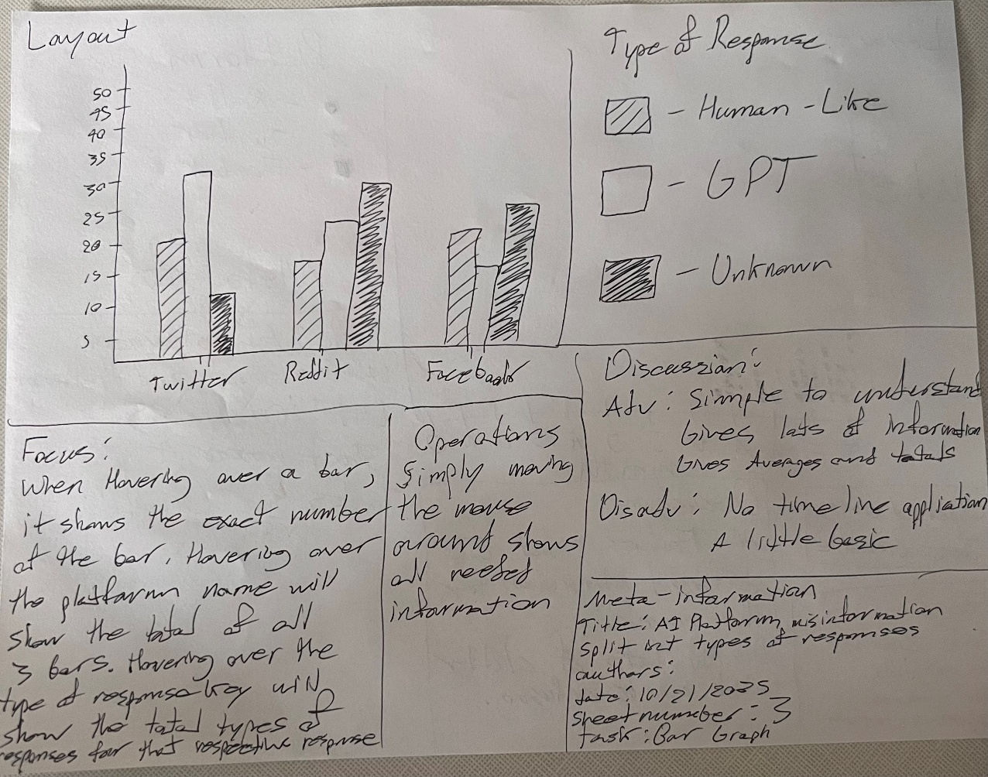
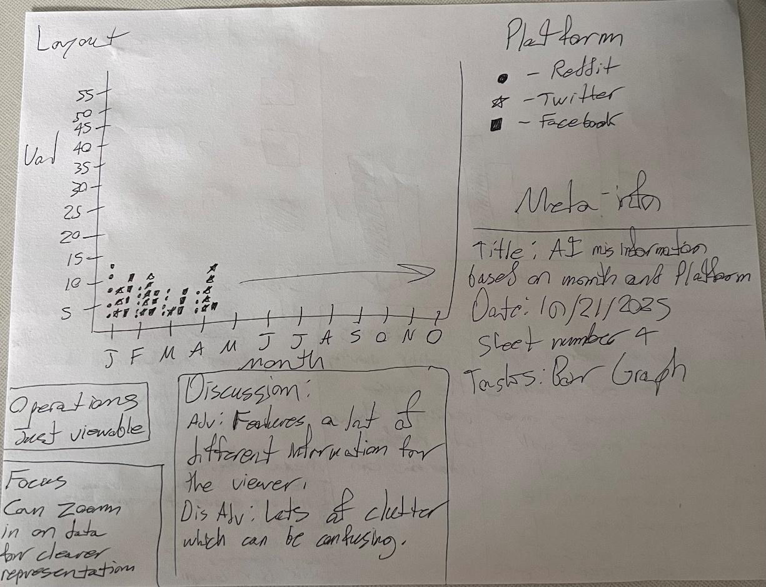
Reflection:
This lab was fun and challenging. It was difficult picking only a few types of data for our charts. If there were too many data points, then the graphs would just get messy. This was a huge tradeoff at the start since many of the points were important to our dataset, but we could only choose a few. Another tradeoff we faced was the type of graphs we settled on. There are many ways to represent our data, but we had to settle on a few in the end. Overall, these challenges guided us to make solid charts for the intended outcome.

Dataset we used:
https://www.kaggle.com/datasets/atharvasoundankar/gen-ai-misinformation-detection-datase-20242025

